**Chapter 8 – SIBLINGS**

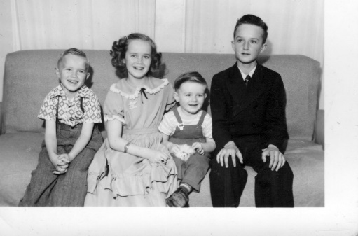

**My brother, Hal, is 18 months older than I**. Mom said he was jealous of me practically from the time I was born. She said he tried to tip over my bassinet many times. He was always teasing me and making me cry. Maybe I cried too easily, but as I remember it, he hurt me a lot – both emotionally and physically. Sometimes he would be pulling me around by my hair or doing wrestle holds on me which hurt me. I would be screaming, and Mom would come in to stop him sometimes, (other times, she would just ignore it) but say to me “Stay away from him; you know you always get the worst of it.” I couldn’t keep away from him as he would come where I was. I remember when I was five years old and got my tonsils out; it was done on our kitchen table while we were living in our basement home. Doctor Tanner used to make “home calls” back then. Just before the doctor was to give me the ether, I remember Hal coming in and saying "Ha, Ha, we're going to have cake and ice cream and you can't have any".

Hal was always a tease while we were growing up. I’m sure it wasn’t Hal’s entire fault, however, because I was feisty and would say plenty back to him. One time when he was sitting in the kitchen watching me do the dishes and clean the kitchen and teasing me saying: “Ha Ha, work harder slave, you have to do all the work and I can go play or do whatever I want, but you have to work, work, work, so work harder, Slave.” I got so angry that I told him to “go play then and get out of here”, but he wouldn’t, as he was bored and liked teasing me, so I was holding a glass and threw it at him, he ducked, it hit the wall and broke. I was the one who got in trouble.

Hal had a good friend; Leonard Rumsey and they did things together. I think they both had inferior complexes, as the other guys in our ward thought they were better than Hal and Leonard and more popular so they were not treated as good or invited to do things and go places with these other guys. Part of it might have been because we lived up on the highway and the others lived in subdivisions west of us and another reason might have been that Mom wasn’t a good housekeeper, so Hal didn’t invite friends over. That was a problem for all of us, but Georgia and Hal the most, I think.

When Hal graduated from High School, Mom & Dad would have liked him to go on a mission, but that wasn’t for Hal. All my other siblings did gain testimonies, but Hal never did. He was a good guy anyway. I remember waking up one morning dreaming that Hal was dead and I was crying so hard. I knew then that I did love him very much. As teenagers we became close and enjoyed each other. We would come home from dates and talk while I fixed us a snack.

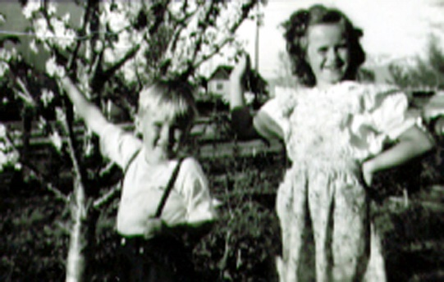**Bryce**: The things I remember about Bryce when he was young, was that he was such a cute little blond boy. He was four years younger than I. The main thing I remember when we were young was that when Hal would tease me, I would go to my big closet in my bedroom and sit on the floor and cry. Bryce would see Hal teasing or hurting me and would feel bad and he knew where I would always go, so he would come in and hug me and tell me he was sorry Hal was mean to me and he tried to comfort me. He was so sweet. However, Georgia tells me that after I was married, Bryce, along with Hal and Terry teased her so much. I wish brothers wouldn’t do that. I think I have mentioned that Mom would want me to take Bryce with me to my friend’s homes when I went to play as when I was 8, 9 or 10 and he was only four, five or six. He was good, so I didn’t mind. Sometimes my friend, Patsy, wished I wouldn’t bring him, but oh well, if I came, so did Bryce. Later, I took Georgia with me.

Bryce became good friends with Ken’s brother, Irven, as they both lived in the same ward. When Ken and I started dating, the two of them would tease us, but I think they thought it was great that we were going together. Bryce & Irven had stayed good friends throughout the years. It was always fun to go to our parent’s homes and be there with these brothers.

Bryce went on a mission to Uruguay in South America. We were all proud of him for going. In those days, family and friends could go to the MTC and stay for the meeting and even go to the airport to see him off. I remember Grandma Bushnell loved Bryce (I think he was her favorite grandchild). She had been in the hospital, but wanted to go see him off, so she revived some and Mom & Dad took her with them, Julie, Bryce’s girlfriend went with them also. Ken and I drove down also and took some of my siblings. We had a couple of hours before Bryce’s flight took off, so we went to a nearby park and had lunch. Grandma was so happy to be there, but when we returned, she got worse again and had to go back to the hospital where she passed away a few days later.

Bryce returned in September 1975 and in February 1976, he was drafted into the Army because the Viet Nam War was on. He had to report in March. He did have a chance, if he would stay in an extra year, to choose what he wanted to be doing, so he did that rather than have to fight on the front lines. He didn’t have a lot of choices, so he became a mechanic repairing the helicopters as they came in. I understand he wasn’t too far from the front lines as he said he could hear the bombs exploding.

Bryce came home on a 30 day leave and asked Ken if there were any cute girls in our ward that he could date. He thought of Deanna Green. As she wasn’t only cute and pretty, but she was smart, kind and has a strong testimony of the gospel. We lined them up and they dated. Bryce left to finish out his Army tour for another year and they wrote back and forth. When he was honorably discharged, they started dating again and married. I was planning to help Deanna and our moms at the reception, but I ended up going in the hospital to have our son, David. I was so happy that it worked out for them as Deanna is the best thing that could have happened to Bryce.

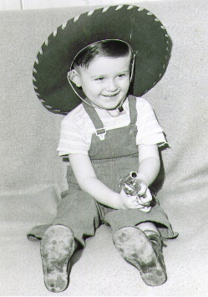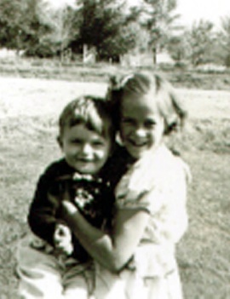**Terry** was a good-looking little guy and he used to like to sit on the couch and bounce his head and upper body, going back and forth. He would do that for the longest time. I wondered if he would hurt himself, but the couch was soft. This is the picture of him sitting on the couch wearing a cowboy hat and holding a toy gun. Terry was a studious boy. He read a lot and was a straight “A” student. Ken & I remember him reading an encyclopedia and asked him why he was doing that. He said he wanted to learn more and this was a good way. Mom & Dad bought an old upright piano and Terry took lessons. He loved the piano and developed his talent on it. You could always tell what kind of mood he was in, by the songs he was playing and how he was playing them. It seemed Terry was either very happy or very unhappy. No one knew until Terry was in High School that he had very poor vision. He was with dad at a basketball game, and a friend called down to him. Terry looked around, but didn’t do anything. This happened a couple more times until dad said: “Terry, why don’t you acknowledge your friend?” Terry said he couldn’t see him. Dad took Terry to the eye doctor soon after, and got him glasses. Terry said he could never see the stars at night or birds in the trees, etc. Since Terry was so tall and big hands, everyone thought he would be great at basketball, but he wasn’t, since he couldn’t see the ball coming until it almost hit him (and it did hit him).

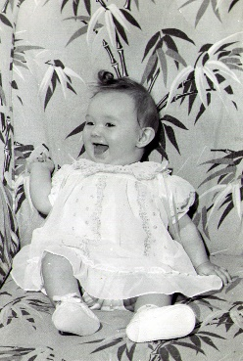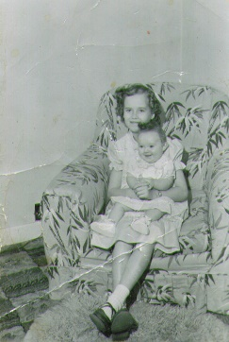**My sister, Georgia**, was born in1951 and boy was I excited as I had wanted a sister as long as I could remember. She was a cute little girl. After she was old enough to be in a big bed, she and I slept together. This wasn’t always fun as she would be on my side when I went to bed, so I would slide her over, and during the night her hands and feet would hit me as she moved around. Another thing that wasn’t so fun was when I would leave for school, she would get in my jewelry and makeup and make a mess of it, but it was still worth it to finally have a sister. Georgia said she had trouble with friends as she grew up also. She, too, was sweet and wouldn’t get angry and fight back when friends took advantage of her, she would just go home and cry and feel bad. Georgia was almost 11 years younger than me - so I was married and lived away most of this time when she was having a hard time with friends and with her brothers, as they teased her unmercifully. She said at the dinner table, if she ever said anything, they would make fun of her. I wish I could have been there for her. Ken & I did invite her to stay the weekends with us sometimes. She loved Sandi and would play with her. We enjoyed having her stay with us. About that time, I was the Stake Activity Counselor and was over camp and after I was released, they asked me to be the Camp Director. One of those years, I had Georgia come to camp with me. She made friends and loved it there.

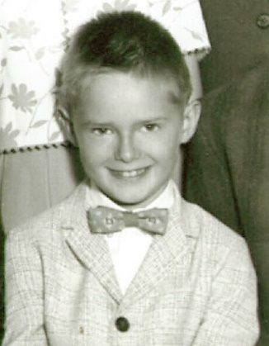**Kim** was in diapers when Ken & I got married. He was a cute little guy. Ken gave him a Tonka Truck for Christmas 1958 when we were engaged.